ASSIGNMENT -1

R Bharath Kumar HALLTICKET NO : 22541A05E3

BAR CHART

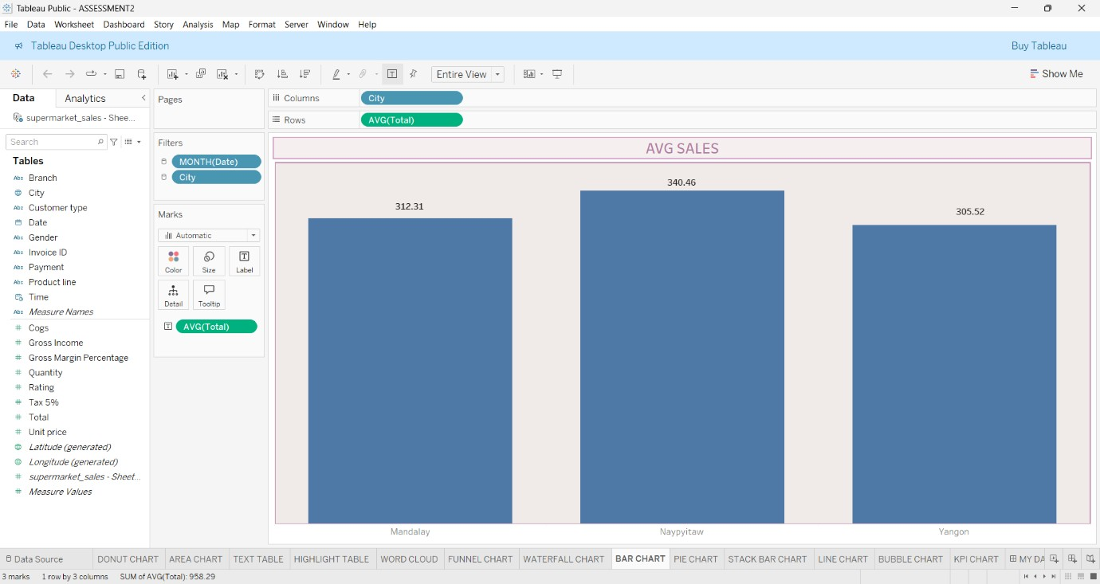

PIE CHART

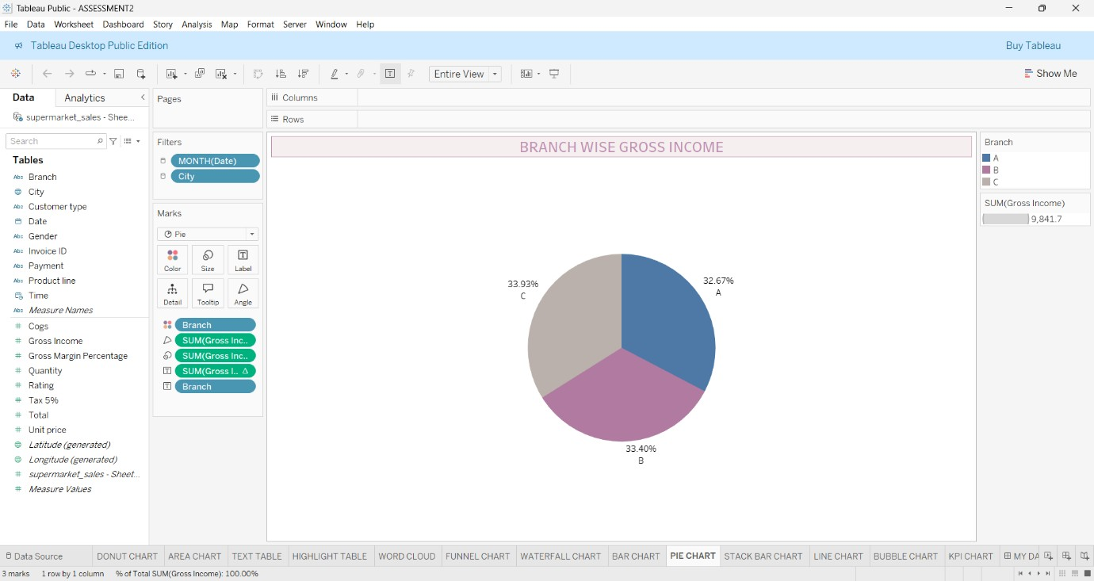

STACK BAR CHART

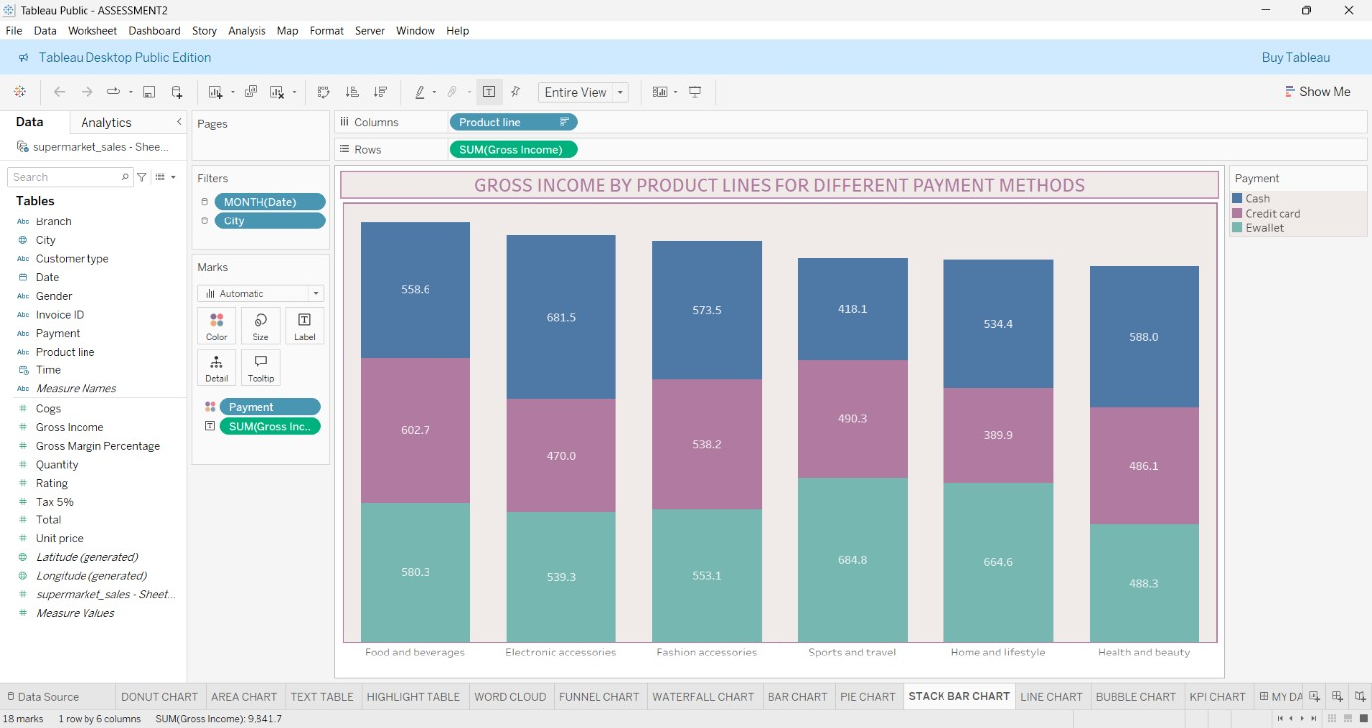

LINE CHART

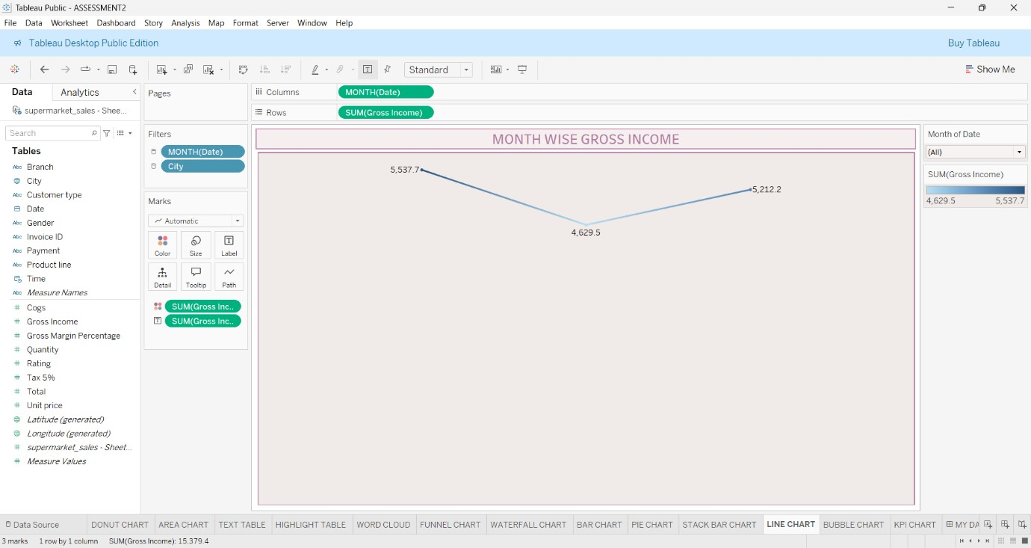

BUBBLE CHART

